

CHE 485 Project

Minimum method in kinetic pathway conjecture based on Monte Carlo and Metropolis-Hasting Algorithm

# Instructor: Chimowitz, Eldred H.

# Mingxuan Li

# Introduction

In chemical engineering research, we always meet some problems that some species can transform to other species easily and in a reactor many species mixed up, in this situation we need to figure out what is the volume of specific species and what is the dominant reaction pathway of the whole reaction series. we can use computer to do the simulation to know. Monte Carlo method is a random algorithm which can simulate many processes by generate random number. and Metropolis-Hasting is a method can help us to accept random numbers to satisfy a specific distribution from a normal distribution.

this is the pathway and nodes we deal with in this project, and the step we do included as following:

Step 1: β,nmax and ε are initialed.

Step 2: get random value of Pij and set into a transition matrix.

Step 3: take the eigenvector of the matrix and named it Πi.

Step 4: give an objective function of φ, and calculate theΔφ.

Step 5: use metropolis algorithm to get Pij we need and store them.

Step 6: running the circle of step 2 to step 5 until times reach the nmax.

Code: 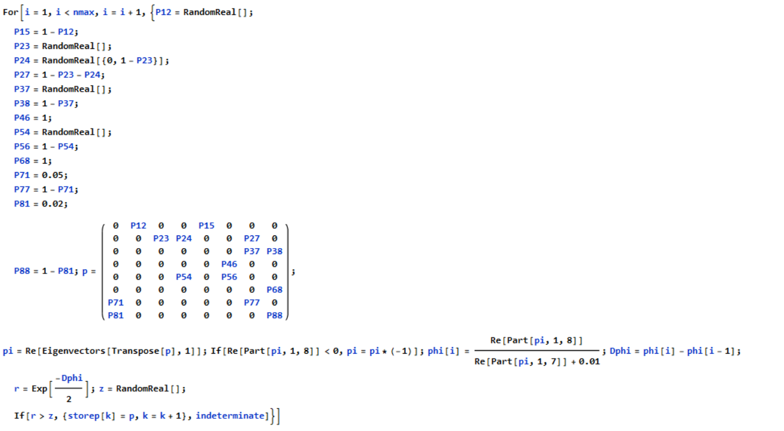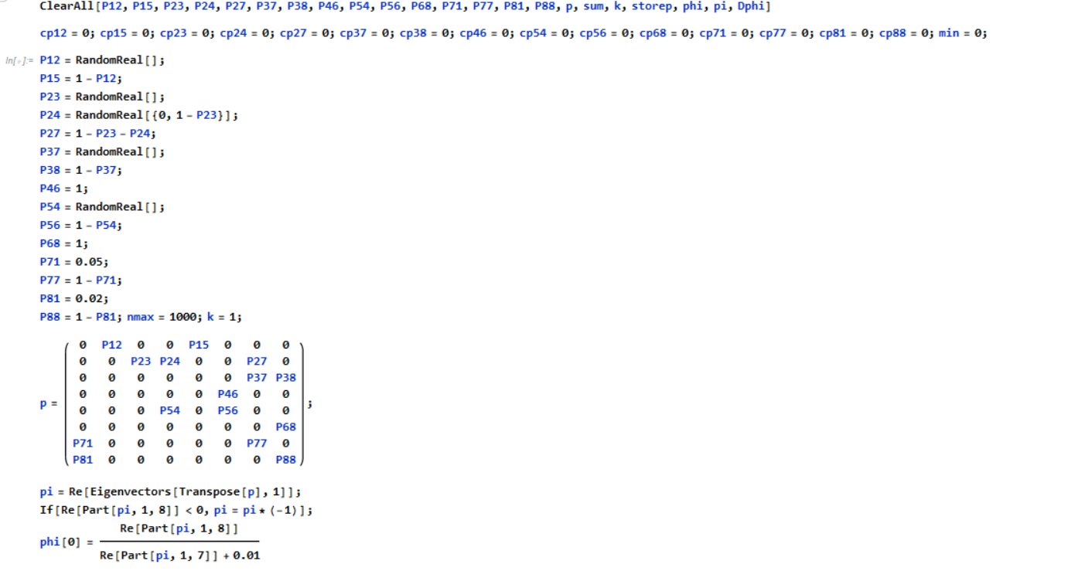

There are two ways to calculate the Pij we got:

1. sum up all the Pij and take the average.

Code: 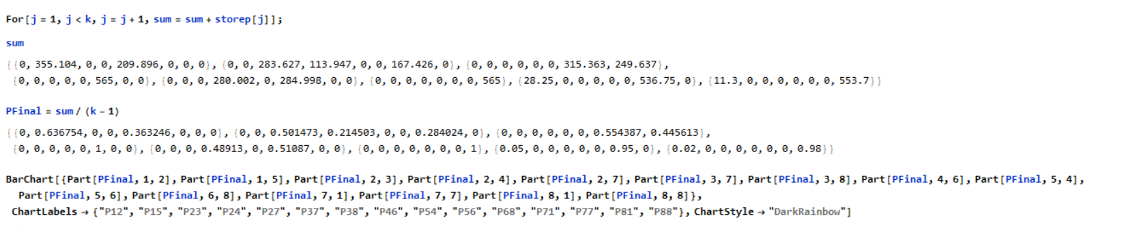

Where we can get the landscape:

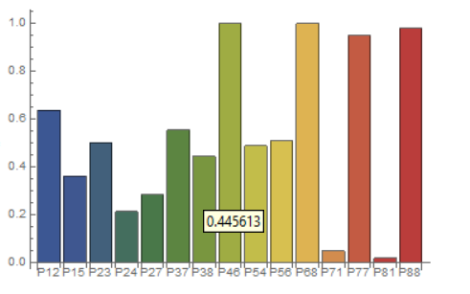

1. another one is use the mimimun method to calsulate:

Code:

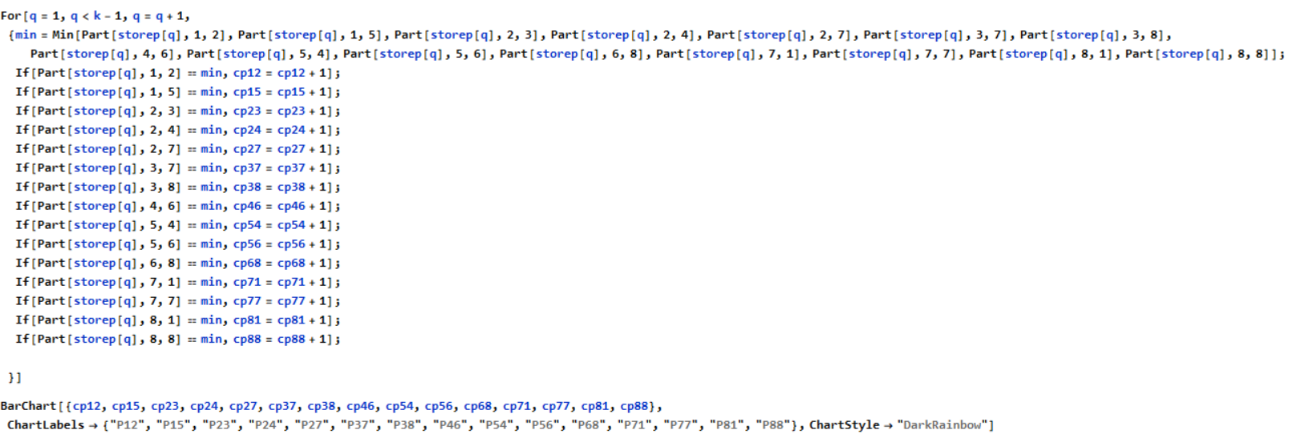

Where we get the landscape:

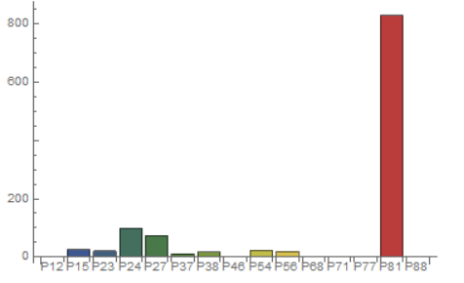

If we change the value of ε, we can see how the landscape change between two ways.

In the following landscape, I change the ε to 0.3.

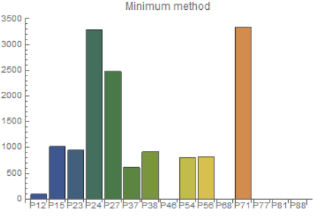

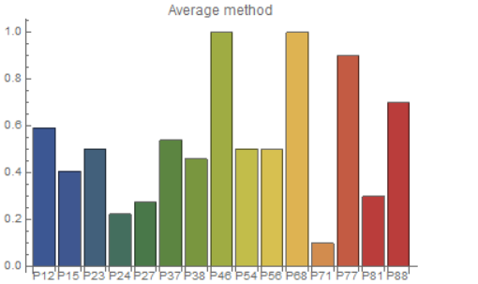

Comparing two charts, We can easily find that minimum method is much more sensitive to detect change of ε, which can be used to detect the rate determined step of a reaction chain.

For the second task, we need to